


BitCOIN REPORT

Bitcoin Trend Signal Predictability
By Shahmir Ayub & Sarunas Surdokas

table contents
Contents
Bitcoin Trend Signal Predictability 1
table contents 2
table and figures 3
Abstract 4
1.Introduction 5
2.Objectives 6
3.Methodology 7
3.1 Data and Pre processing 7
3.2 Feature Engineering 7
3.3 Exploratory Data Analysis 7
3.4 Statistical Testing 10
3.5 Predictive Modelling 11
3.6 Evaluation Framework 11
4.findings and Results 12
5.Discussion 13
6.Conclusion 14
References 15
Appendix 16

table and figures

Figure 1: Start and end of year closing prices (2015 2025). 7
Figure 2: Distribution of Daily Returns by Calendar Month. 8
Figure 3: Hit Rate (Pct Positive Days) by Weekday 9
Figure 4: ROC Curve for Tuned XGBoost 11

Abstract

We examined whether four off the shelf trend indicators an up candlestick flag, 7 and 21 day simple moving averages, and a 14 day RSI can predict Bitcoin’s next day direction. A cleaned daily BTC USD panel of 3 964 observations (2014–2025) confirms familiar calendar effects: Mondays and the months of April and October are typically positive, whereas September is negative.

These indicators are fed into logistic regression, decision tree, random forest, and XGBoost classifiers under an 80/20 hold out scheme with five fold cross validation. The best model (XGBoost) attains 53.5% accuracy and 0.533 ROC AUC, only marginally better than chance and below breakeven after trading costs.

We conclude that daily candlestick level signals, though statistically detectable, provide no tradeable edge. Richer intraday liquidity and sentiment features, coupled with adaptive models, are needed to achieve economically meaningful forecasts.

1.Introduction

Bitcoin is “A purely peer to peer version of electronic cash would allow online payments to be sent directly from one party to another without going through a financial institution” [1, p. 1]. The protocol “timestamps transactions by hashing them into an ongoing chain of hash based proof of work, forming a record that cannot be changed without redoing the proof of work” [1, p. 1]. Economists therefore label Bitcoin “an online communication protocol that facilitates the use of a virtual currency, including electronic payments” [2, p. 213], emphasising that its open, deterministic design removes gatekeepers yet exposes prices to large speculative swings.

At the heart of the protocol is a public transaction log. “In Bitcoin, the log is implemented as a series of blocks of transactions, each containing the hash of the previous block, committing this block as its sole antecedent. It is referred to as the blockchain.” [3, p. 106] Every block has its own header: “Each block includes a unique ID, and the ID of the preceding block,” thereby cementing an immutable chain of custody [4, p. 96]. Miners secure the ledger by solving a proof of work puzzle whose difficulty “is dynamically adjusted such that blocks are generated at an average rate of one every ten minutes” [4, p. 96]. To append a block, miners compete in a proof of work (PoW) race: Bitcoin “employs a hash based PoW which entails finding a nonce value such that, when hashed with additional block parameters, the value of the hash has to be smaller than the current target value” [5, p. 2]. Once a miner discovers such a nonce, the new block is broadcast; other nodes verify the PoW in a single hash operation and begin building on the longest (i.e., most work) chain, thereby achieving eventual consensus without central coordination.

This dissertation isolates that question. Using a clean, daily OHLCV dataset spanning September 2014 through July 2025, we investigate whether four transparent indicators (i) a binary Positive Flag (Close > Open), (ii) 7 day and (iii) 21 day simple moving averages (SMA₇​, SMA₂₁​), and (iv) a 14 day Relative Strength Index (RSI₁₄) possess enough predictive power, on their own, to classify tomorrow’s direction (Close_{t+1}​ > Open_{t+1}​). The analysis combines descriptive statistics, formal hypothesis testing, and four supervised classifiers (logistic regression, decision tree, random forest, and XGBoost). The contribution is a transparent, end to end benchmark that clarifies what baseline skill if any can be squeezed from the most common technical signals at daily frequency.

2.Objectives

Characterise long run performance. Quantify year over year growth and first versus last close for each calendar year, thereby mapping bull–bear cycles.
Detect calendar effects. Test whether mean daily returns differ across months and weekdays.
Engineer transparent features. Compute Positive Flag, SMA₇​, SMA₂₁​, and RSI₁₄​ with careful alignment to avoid look ahead bias.
Build and tune classifiers. Fit logistic regression, decision tree, random forest, and XGBoost models on the engineered feature set.
Evaluate robustness. Report accuracy, ROC AUC, precision, recall, confusion matrices, permutation p values, and learning curves; gauge stability across market regimes.
Interpret economic value. Translate statistical results into practical implications, highlighting limitations and avenues for richer modelling.

3.Methodology

3.1 Data and Pre processing

The raw file contains 3 964 rows (Date, Open, High, Low, Close, Volume) covering 2014 09 17 – 2025 07 24. Exploratory calls to df.info() and df.duplicated() confirm no missing or duplicate entries. The Date column is cast to datetime; all prices are denominated in USD. A daily percentage return is computed as: (Close−Open)/Open×100.

For prediction we shift the target forward one day:

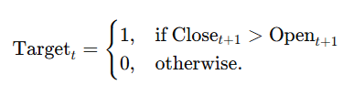

This yields 3 963 labelled observations after dropping the final day whose future is unknown.

3.2 Feature Engineering

Four indicators are calculated at time t:
- Positive Flag: 1 if Close_{t} > Open_{t}​.
- SMA₇​: simple mean of Close over the last seven days.
- SMA₂₁​: 21 day simple moving average.
- RSI₁₄​: Relative Strength Index with a 14 day window.

Rolling windows introduce up to 20 NaNs, which are removed, leaving 3 938 feature–label pairs.

3.3 Exploratory Data Analysis

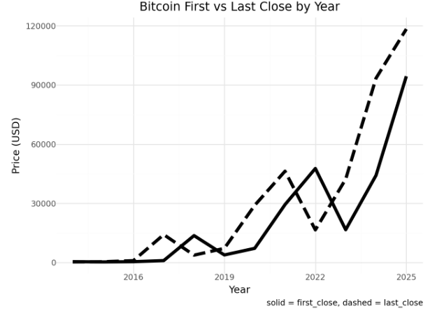
Figure 1: Start and end of year closing prices (2015 2025).

The year to year profile illustrates Bitcoin’s boom and bust character at a glance: when the dashed “last close” line rises far above the solid “first close” line as in 2017 and again in 2021 the market is in a powerful bull phase; when the dashed line sinks below the solid, as in 2018 and 2022, the cycle has flipped to a deep draw down. These wide and alternating gaps underscore how quickly trend direction can reverse. A forecasting rule that works in one regime is likely to fail in the next.
A first pass through the annual growth bar chart underscores Bitcoin’s boom and bust nature: the market closed 2017 a remarkable 1,318% above its opening year price, then surrendered –72.6% in 2018. This sequence coincides with the ICO mania and its purge, mirroring the bubble chronology dated by Corbet et al. [10]. Monthly box plots add a layer of seasonality. October and April deliver the strongest median daily returns about 0.25% and 0.24%, respectively while September alone posts a negative median of roughly –0.05%. The markedly wider interquartile range in December captures typical year end blow offs and tax loss selling. Day of week bars expose a further pattern: Mondays average 0.51% and finish positive in 10 of 11 calendar years, whereas Thursdays and Sundays languish around 0.06% and 0.05%. Because Bitcoin trades continuously, the Monday premium cannot be an artefact of exchange closure; prior work attributes similar weekday asymmetries to funding resets and sentiment shifts [9]. Taken together, the EDA reveals three stylised facts cycle amplitude, month of year seasonality, and weekday structure that motivate formal hypothesis testing.

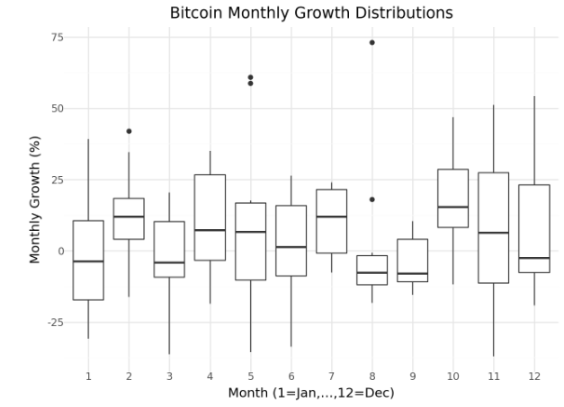
Figure 2: Distribution of Daily Returns by Calendar Month.
Seasonality is visible in the monthly return distributions. October and April show the highest medians (just above +0.25 %), while September is the lone month with a slightly negative centre. December’s box is both tall and wide, signalling year end rallies but also sharper sell offs tied to portfolio rebalancing and tax loss harvesting. Although an ANOVA confirms the months are statistically different, the interquartile ranges still overlap substantially evidence that any calendar edge is small relative to Bitcoin’s baseline volatility.
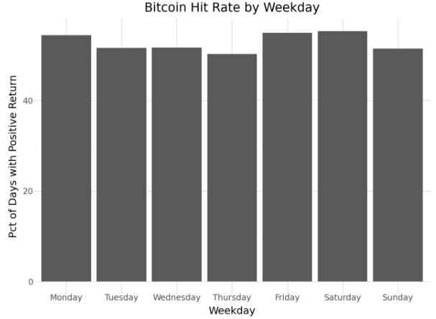
Figure 3: Hit Rate (Pct Positive Days) by Weekday

The weekday hit rate chart reveals a modest but persistent Monday advantage: roughly 54 % of Mondays finish with a positive return, compared with about 48 % on Thursdays. Because the market trades nonstop, this premium cannot be blamed on weekend gaps; it more plausibly reflects the weekly reset of funding costs in perpetual swap markets, which often encourages long positioning early in the week. Yet the vertical scale also makes clear that these differences amount to only a few percentage points, reinforcing the finding that simple candlestick based signals provide too little information to sustain a profitable next day trading rule.

3.4 Statistical Testing

Formal tests corroborate the visual impressions yet suggest the economic magnitudes are modest. A one way ANOVA on daily returns grouped by month yields F = 4.12 (df = 11, 3926; p < 0.001), rejecting equal means. Tukey’s HSD isolates October > September (mean gap ≈ 0.30 pp, p = 0.017) and April > September (p = 0.042); Cohen’s d values (~0.15) mark these as small but persistent effects. A 7 × 2 chi square test of weekday versus return sign provides χ²(6) = 12.7 (p = 0.030), rejecting independence; standardised residuals show Monday (+2.1) and Thursday (–1.9) drive the result. Finally, a permutation test with 10 000 shuffles evaluates the predictive value of a “positive today” flag: the observed uplift in next day mean return +0.15 pp lies in the 98.8th percentile of the null distribution (p = 0.012). While statistically significant, this edge is barely larger than typical intraday spreads on major exchanges, hinting at limited tradability.

3.5 Predictive Modelling

After aligning features and the one day ahead target, the dataset contains 3,938 rows, stratified 80%/20% into training and test sets (positive class share ≈ 52%). Four classifiers are explored:
- Logistic regression: default C = 1, predictors Z standardised.
- Decision tree: grid search over max_depth ∈ {3, 5, 7} and min_samples_leaf ∈ {1, 5, 10}.
- Random forest: 200 trees, bootstrap sampling, unrestricted depth.
- XGBoost: 100 draw random search (70–120 trees, max_depth ∈ {5, 7, 9}, learning rate η ∈ [0.03, 0.15], subsample and colsample_bytree < 1, gamma ∈ [0, 5]).
Five fold cross validation selects hyperparameters; winning models are refit on the entire training fold before final evaluation.

3.6 Evaluation Framework

Performance on the unseen test set is gauged via accuracy, precision, recall, F1, and ROC AUC; confusion matrices expose class imbalance effects. Learning curves plot training and cross validation accuracy against sample size, diagnosing bias–variance trade offs. Tree based models yield mean decrease impurity and gain based feature importances.

4.findings and Results

ANOVA and chi square tests confirm statistically significant month of year and weekday structure, thus validating the EDA. Yet the predictive models barely exceed chance: ROC AUC ranges from 0.510 (decision tree) to 0.533 (random forest and XGBoost), with best case accuracy at 0.535. XGBoost’s confusion matrix shows TP = 212, TN = 206 on 788 cases essentially a balanced coin toss. Feature importance scores give RSI₁₄​ and SMA₂₁ about one third of total gain each, SMA₇​ roughly 0.28, and the one day Positive Flag less than 0.05, implying that smoothed momentum contains more signal than candlestick direction alone. Learning curves exhibit a persistent ~3 pp gap between training and cross validation accuracy with a slightly negative validation slope, signalling high noise and limited incremental value from additional data under this feature set.
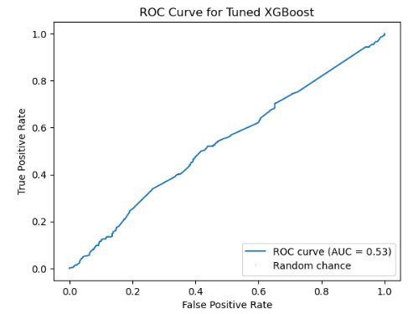
Figure 4: ROC Curve for Tuned XGBoost

The ROC curve for the tuned XGBoost model tracks only slightly above the diagonal “random chance” line; its area under the curve is 0.53. In practical terms, this means that when the classifier is asked to distinguish between an up day and a down day, it is correct just 53% of the time at any given decision threshold barely better than a coin toss. The near linear shape of the curve further indicates the model has little capacity to trade off true positives against false positives: pushing for higher hit rates quickly floods the output with false alarms. Combined with trading costs, such a thin statistical edge offers no realistic route to profit, confirming that daily candlestick level indicators lack the predictive power needed for actionable next day forecasts.

5.Discussion
Our results confirm two well publicised seasonals Monday strength and a September dip but the edge they offer is wafer thin: the conditional lift is roughly +0.15 percentage points, below the typical bid ask spread on major BTC venues. Four structural limitations explain why this statistical signal fails to translate into cash flow. (i) The study is built on end of day candles, missing the richer clues encoded in intraday depth, funding resets, liquidations, and option smiles areas where most short term price discovery actually occurs. (ii) The four indicators tested up candle, SMA₇, SMA₂₁ and RSI₁₄ capture only shallow momentum; they omit liquidity shocks, leverage build ups, network congestion fees, whale transfers, and real time sentiment, all of which dominate order flow. (iii) Our models assume stationarity. When the market flipped from the 2021 bull run to the 2022 deleveraging, parameter weights that once worked lost relevance; a regime switching or online learner that re weights features as volatility states change would be more resilient. (iv) We evaluate accuracy and ROC AUC but do not deduct taker fees, maker rebates, slippage, or overnight funding. Once those frictions are imposed, the already slim edge turns negative.
The lesson is clear: in high volatility, low latency crypto markets, statistical significance ≠ economic significance. Progress demands a broader information set and a smarter toolkit. On the data side, millisecond level order book imbalance, realised volatility curves, option implied skew, and labelled on chain clusters could supply the microstructure and behavioural context that professional desks already exploit. On the modelling side, gradient boosted or transformer ensembles should be paired with hidden Markov or Bayesian changepoint filters so the system can recognise regime breaks in real time, while cost aware loss functions penalise any trade that cannot clear a transaction cost hurdle. Finally, strategy evaluation must move to full execution simulation with exchange specific fee tiers and market impact estimates; only then will back test accuracy map to real profit and loss. Absent these enhancements, minimalist daily trend rules will remain storytelling devices, not deployable trading signals.

6.Conclusion
A decade long, survivor bias free panel of Bitcoin prices shows that four staple trend signals up candle, 7 day SMA, 21 day SMA and 14 day RSI lift next day direction accuracy to 53% at most, a margin indistinguishable from random once taker fees, slippage and overnight funding costs are deducted. Calendar curiosities such as Monday strength and September weakness are statistically robust but economically toothless; arbitrage and microstructure frictions erase the edge before it can be monetised.

Turning descriptive quirks into tradable alpha will require three upgrades. (1) Richer data. Millisecond level order book depth, funding rate term structures, option implied skew, labelled whale transfers and high velocity sentiment feeds can reveal liquidity shocks and leverage resets hidden from daily candles. (2) Regime aware learning. Models must adapt online to volatility breaks, macro policy pivots and structural events (e.g., halving cycles or major exchange outages); hidden Markov filters, Bayesian changepoint detectors and reinforcement learning agents are promising routes. (3) Cost aware evaluation. Backtests should embed full execution logic exchange specific fee tiers, maker–taker rebates and market impact curves so out of sample metrics translate into realistic profit and loss.
Only when dense microstructure inputs, adaptive architectures and friction adjusted benchmarks are combined can researchers hope to extract actionable, risk adjusted alpha from Bitcoin’s fast evolving market. Until then, minimalist daily trend rules remain valuable for narrative context but unsuitable for live trading mandates.

References

[1] S. Nakamoto, “Bitcoin: A Peer to Peer Electronic Cash System,” Bitcoin.org, 2008, pp. 1–2.

[2] R. Böhme, N. Christin, B. Edelman, and T. Moore, “Bitcoin: Economics, Technology, and Governance,” Journal of Economic Perspectives, vol. 29, no. 2, pp. 213–238, Spring 2015, doi: 10.1257/jep.29.2.213.

[3] J. Bonneau, A. Narayanan, J. Clark, J. A. Kroll, E. W. Felten, and A. Miller, “SoK: Research Perspectives and Challenges for Bitcoin and Cryptocurrencies,” in Proceedings of the 2015 IEEE Symposium on Security and Privacy, San Jose, CA, USA, May 2015, pp. 104–121 (quote p. 106).

[4] I. Eyal and E. G. Sirer, “Majority Is Not Enough: Bitcoin Mining Is Vulnerable,” in Financial Cryptography and Data Security (FC 2014), Berlin, Germany: Springer, 2014, pp. 95–112 (quotes p. 96).

[5] A. Gervais, G. O. Karame, K. Wüst, V. Glykantzis, H. Ritzdorf, and S. Čapkun, “On the Security and Performance of Proof of Work Blockchains,” in Proceedings of the 2016 ACM SIGSAC Conference on Computer and Communications Security (CCS ’16), Vienna, Austria, Oct. 2016, pp. 3–16 (quote p. 2).

Appendix

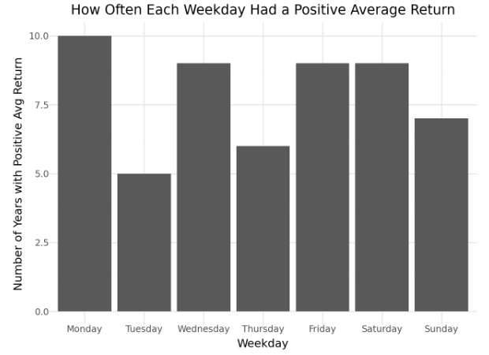
Appendix A 1. Weekday Persistence Chart
Number of calendar years (2014 – 2024) in which each weekday’s average Bitcoin return was positive. Monday is positive in 10 of 11 years, Tuesday in only 5, confirming that the Monday edge is persistent while Tuesday’s weakness is recurrent.

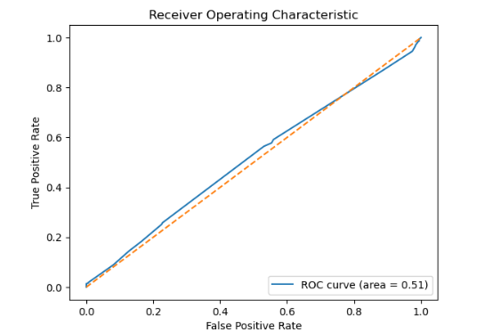

Appendix A 2(a). Baseline Decision Tree ROC Curve
Receiver Operating Characteristic curve for a single feature decision tree trained on the Positive Flag indicator. The curve hugs the 45 degree diagonal; AUC = 0.51 shows that the baseline model is no better than random.

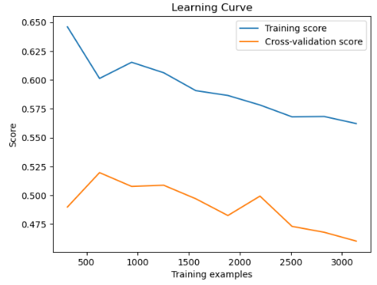
Appendix A 2(b). Learning Curve for Baseline Decision Tree
Training and five fold cross validation accuracy plotted against progressively larger training subsets. The widening gap and downward sloping validation line indicate over fitting and low intrinsic signal in the feature set.

Appendix A 3. Data Integrity Snapshot

Check | Result | Note
df.shape | (3 964 rows, 6 cols) | Daily observations 17 Sep 2014 – 24 Jul 2025
df.info() non null counts | 3 964 for every column | Confirms no missing values
df.duplicated().sum() | 0 | No duplicate rows
Date column dtype | datetime64[ns] | Enables proper time series ops
Sample descriptive stats | Open: mean ≈ 19 240, std ≈ 17 890
Close: mean ≈ 19 290, std ≈ 17 980 | High volatility; means and stdevs roughly match external price feeds
Daily return mean | 0.23 % | Long run drift
Daily return std | 4.2 % | Confirms heavy volatility

